
INDIAN SCHOOL AL WADI AL KABIR
Class: X | Department: Social Science | Sub: History
Chapter-2  Work Sheet | Topic: Nationalism in India | Year: 2025-26
1 | Choose the appropriate chronological order for the events given below:  (i) Arrival of Simon Commission in India  (ii) Demand of Purna Swaraj in Lahore Session of INC  (iii) Government of India Act, 1919  (iv) Champaran Movement  Options:  A. (iii) – (ii) – (iv) – (i)  B. (i) – (ii) – (iv) – (iii)  C. (ii) – (iii) – (i) – (iv)  D. (iv) – (iii) – (i) – (ii)
2 | Which one of the following agreements gave reserved seats to the ‘Depressed classes’ in the Provincial and Central Legislative councils?  A. Lucknow Pact  B. Gandhi-Irwin Pact  C. Poona Pact  D. Lahore Pact
3 | The Plantation workers were not permitted to leave the tea gardens without permission as per the_________.  A. Inland Emigration Act of 1859  B. Inland Emigration Act of 1866  C. Inland Emigration Act of 1879  D. Inland Emigration Act of 1869
4 | Consider the statements given below and choose the correct answer  Statement I: At the Calcutta session of the Congress in September 1920, Gandhiji convinced other leaders of the need to start a non-cooperation movement in support of Khilafat as well as for swaraj  Statement II: Forced recruitment is a process by which the colonial state forced people to join the army  A. Statement I is correct and II is incorrect.  B. Statement I is incorrect and II is correct  C. Both I &II are incorrect  D. Both I &II are correct
5 | Which among the following factors explains the impact of worldwide depression on Indian agriculture?  A. Decline in exports  B. Reduction in revenue by landlords  C. Abolition of begar  D. Emergence of farmer’s union
6 | Identify the correct option that describes the Act given below.  i. The Act was passed by the Imperial Legislative Council.  ii. It gave power to the government to repress political activities.  iii. It empowered the government to detain political prisoners without trial.  Options:  A. Rowlatt Act  B. Vernacular Press Act  C. Government of India Act  D. Inland Emigration Act
7 | Who formed the ‘Swaraj Party’ within the Congress?  A. Jawahar Lal Nehru and Motilal Nehru  B. Abdul Ghaffar Khan and Mahatma Gandhi  C. Jawahar Lal Nehru and Subhas Chandra Bose  D. C.R. Das and Motilal Nehru
8 | The resolution of Purna Swaraj was adopted at which session of the Congress?  A. Bombay  B. Lahore  C. Karachi  D. Madras
9 | Assertion (A): Some of the Muslim political organizations in India were lukewarm in their response to the Civil Disobedience Movement.  Reason(R): After the decline of the Non-Cooperation-Khilafat movement, a large section of Muslims felt alienated from the Congress.  Options:  - Both A and R are true and R is the correct explanation of A.  - Both A and R are true and R is not the correct explanation of A.  - A is true but R is false.  - D.A is false but R is true.
10 | 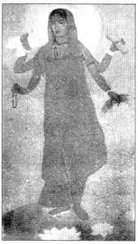  How is Bharat Mata portrayed in the above picture?  A.Ascetic  B.Divine  C.Spiritual  D.All of the above
11 | 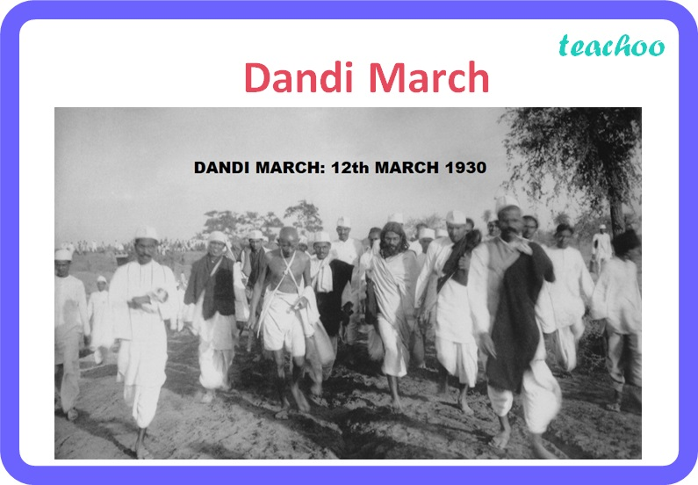  Which of the following event was related to the image of Gandhiji given in the picture?  A. Non-Cooperation Movement  B. Kheda Satyagraha  C. Dandi March  D. None of the above

